The Uses of Fluids

A fluid is anything that DOES NOT have fixed shape and can flow (usually a liquid or a gas). One of the reasons that fluids are so useful is that they make it easier to **transport**, **process**, and **use** different kinds of materials; even if those materials are solids.

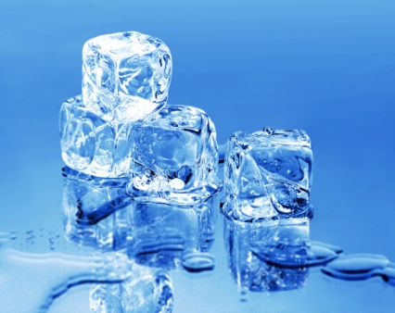

1. Make a list of fluids you see in figure 1.5 (pg 13) and how they are being used:
2. Define slurry.
3. What is slurry technology and why is it important?
4. Give two examples of fluids that become solids. Explain why manufacturers do this.
5. The ability of fluids to spread or flow and carry to other materials makes them useful. Give two examples of when this happens.

List at least 7 uses of fluids (for some hints look at pg 16):

-

-

-

-

-

-

-

C:\Documents and Settings\ginaotte\Local Settings\Temporary Internet Files\Content.IE5\G2X12HPM\MC900250570[1].wmf